you have the right to be free from sexual abuse and sexual harassment  You also have the right to:  - Make a report if you are sexually abused or sexually harassed.  - Not be punished for making a report.  - Get free medical and mental health care related to sexual abuse and sexual harassment.  - Get help from a victim advocate from an outside agency. |  | Sexual abuse and sexual harassment are never OK – no matter what |  | Know Your Rights  Prison Rape Elimination Act (PREA)
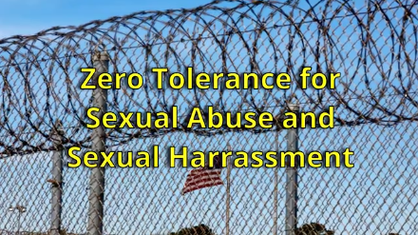 |  | Department information: |  | DEPARTMENT LOGO

definitions  What is sexual abuse?  - Sexual touching by another inmate that you do not want.  - Any time someone who works here touches or looks at your private parts, and is not part of their duties, whether you felt okay with it or not.  - Any requests or demands  for sexual favors by someone who works or volunteers here.  What is sexual harassment?  - Any sexual comments or gestures from someone who works or volunteers here.  - Insulting, repeated comments about your body, sexual orientation, or gender from someone who works  or volunteers here.  - Unwanted and repeated sexual comments or requests for sex from other inmates. |  | how to get help  You can talk to a trained rape crisis advocate for free. These calls are not monitored and not recorded.  Call an advocate at:  Add the information for the local RCC here. The # detainees call that is free and not recorded.  Mail an advocate at:  Add the mailing address here to local Rape Crisis Center that serves your facility |  | making a report  Every report of sexual abuse or sexual harassment is investigated  You can report without using your name or the name of the abuser  To make a report, you can:chk info  - Tell any staff person or volunteer  - File a written grievance  - File a medical or mental health request  You can also report here:  Add the information here

